Figure-1.1.1 Verilog Source code for 8-stage 32-bit Adder part 1
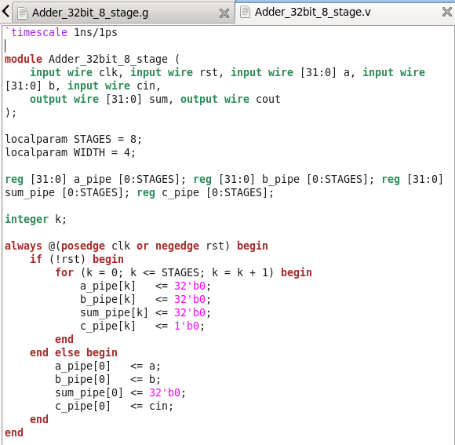
Figure-1.1.2 Verilog Source code for 8-stage 32-bit Adder part 2
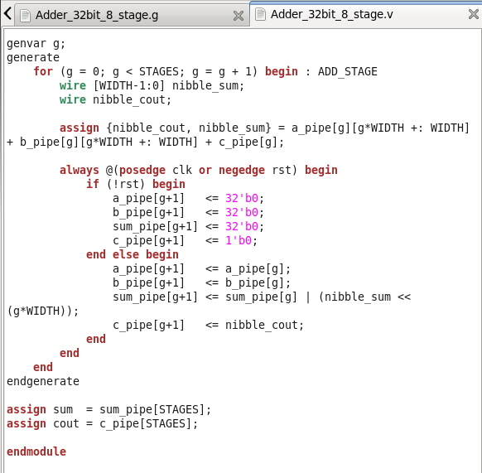

Figure-1.2.1 Verilog Source code for 8-stage 32-bit Adder Test-bench part 1
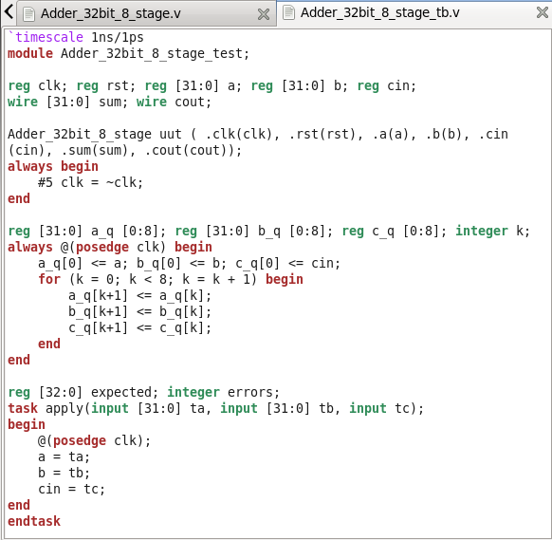
Figure-1.2.1 Verilog Source code for 8-stage 32-bit Adder Test-bench part 2
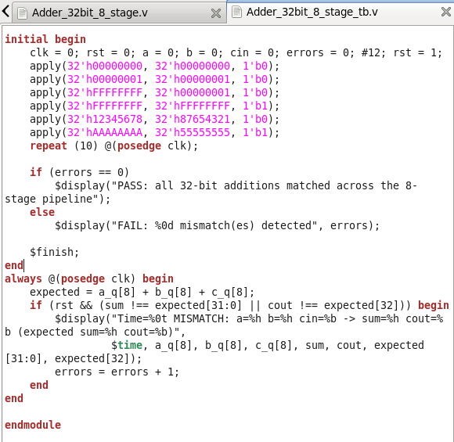

Figure-1.3. NCLaunch window of 8-stage 32-bit Adder showing successful compilation (no errors in the Command Entry Window)
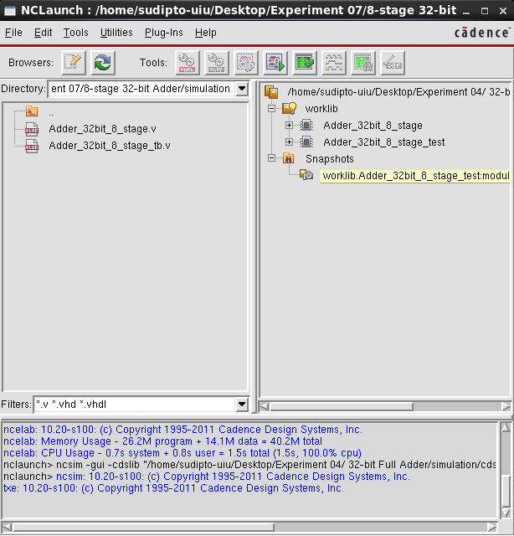

Figure-1.4. SimVision window for 8-stage 32-bit Adder Test-bench, showing the inputs, selector lines, and output
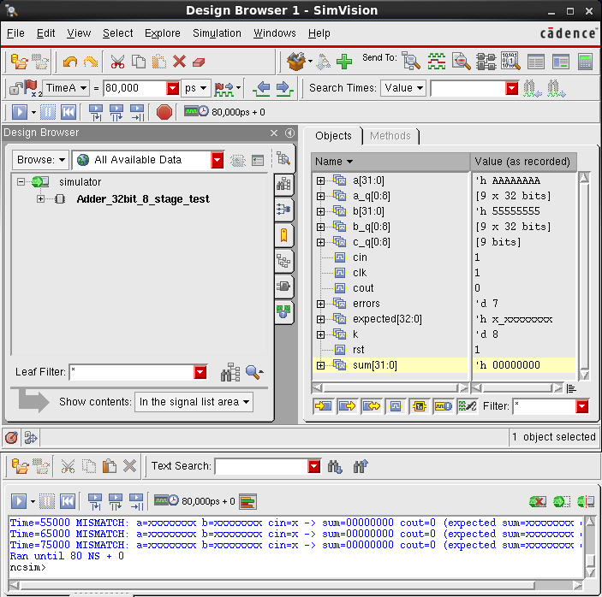

Figure-1.5.1. SimVision Output Waveform for 8-stage 32-bit Adder Test-bench, showing the all inputs, selector lines, and output
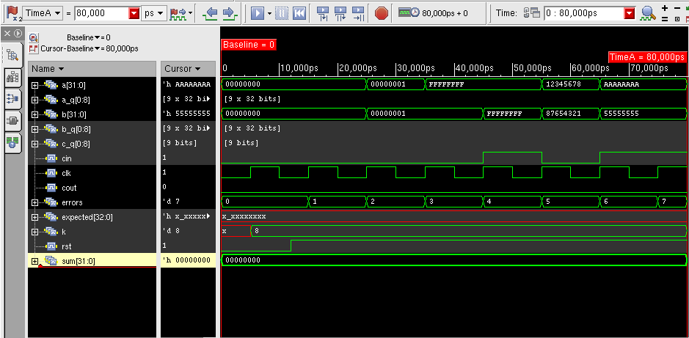

Figure-1.5.2. SimVision Output Waveform for 8-stage 32-bit Adder Test-bench, showing the input(A), selector lines, and output
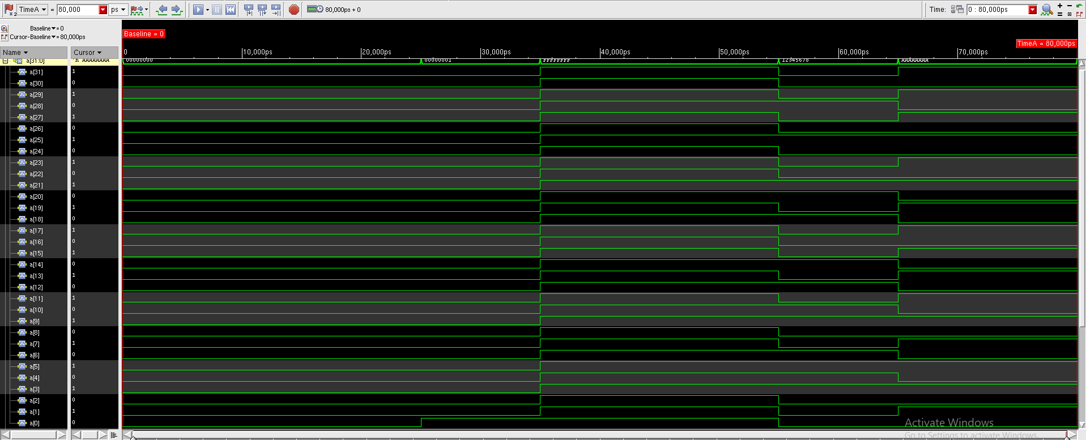

Figure-1.5.3. SimVision Output Waveform for 8-stage 32-bit Adder Test-bench, showing the input(a_q, b_q, c_q), selector lines, and output
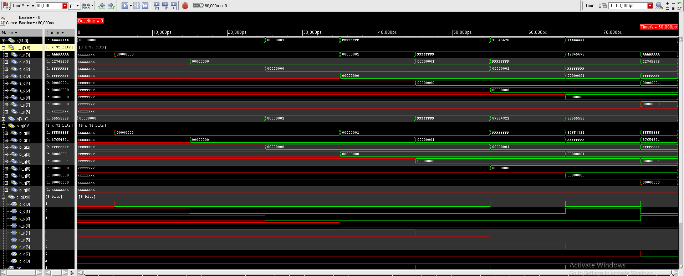

Figure-1.5.4. SimVision Output Waveform for 8-stage 32-bit Adder Test-bench, showing the input(B), selector lines, and output
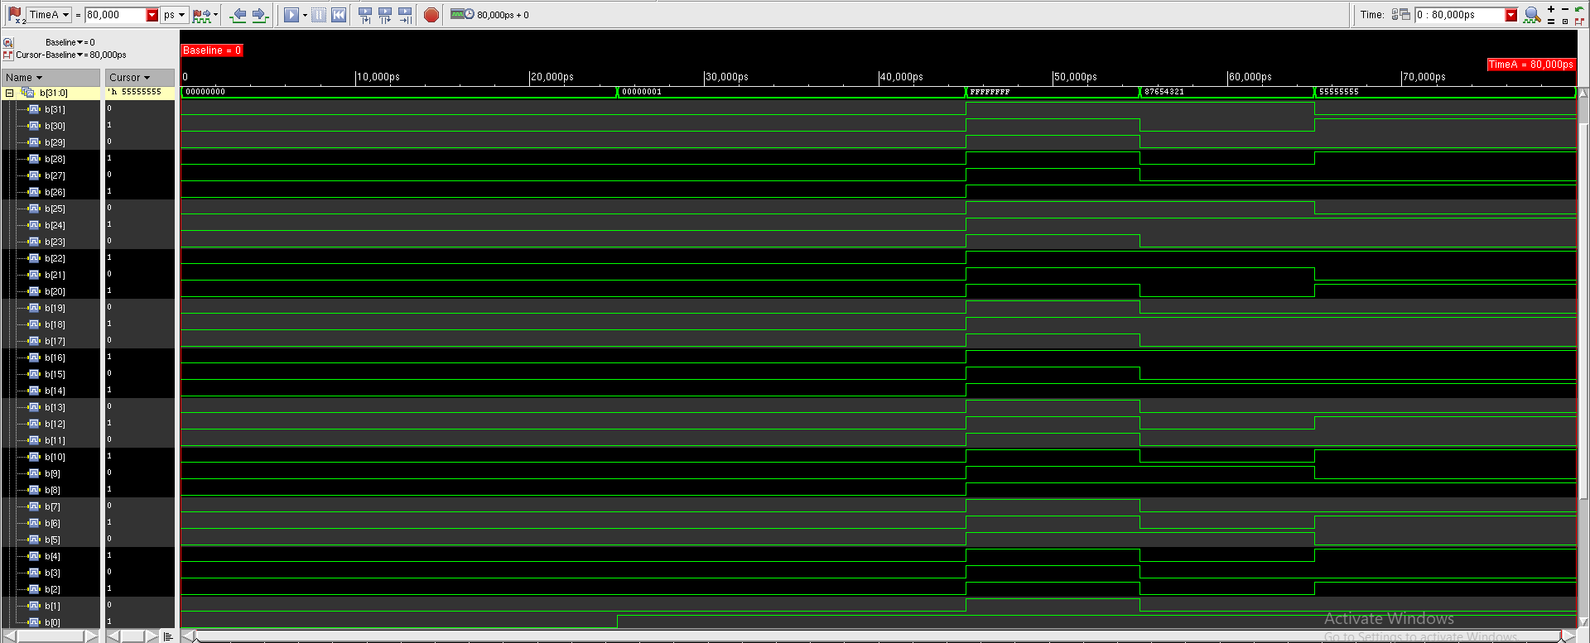

Figure-1.5.5. SimVision Output Waveform for 8-stage 32-bit Adder Test-bench, showing the output(error), selector lines, and input
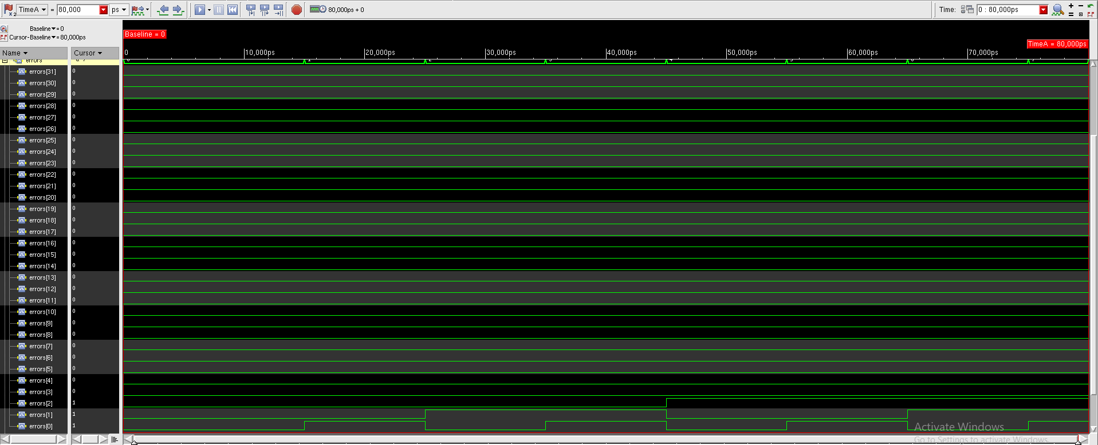

Figure-1.5.6. SimVision Output Waveform for 8-stage 32-bit Adder Test-bench, showing the sums, selector lines, and output
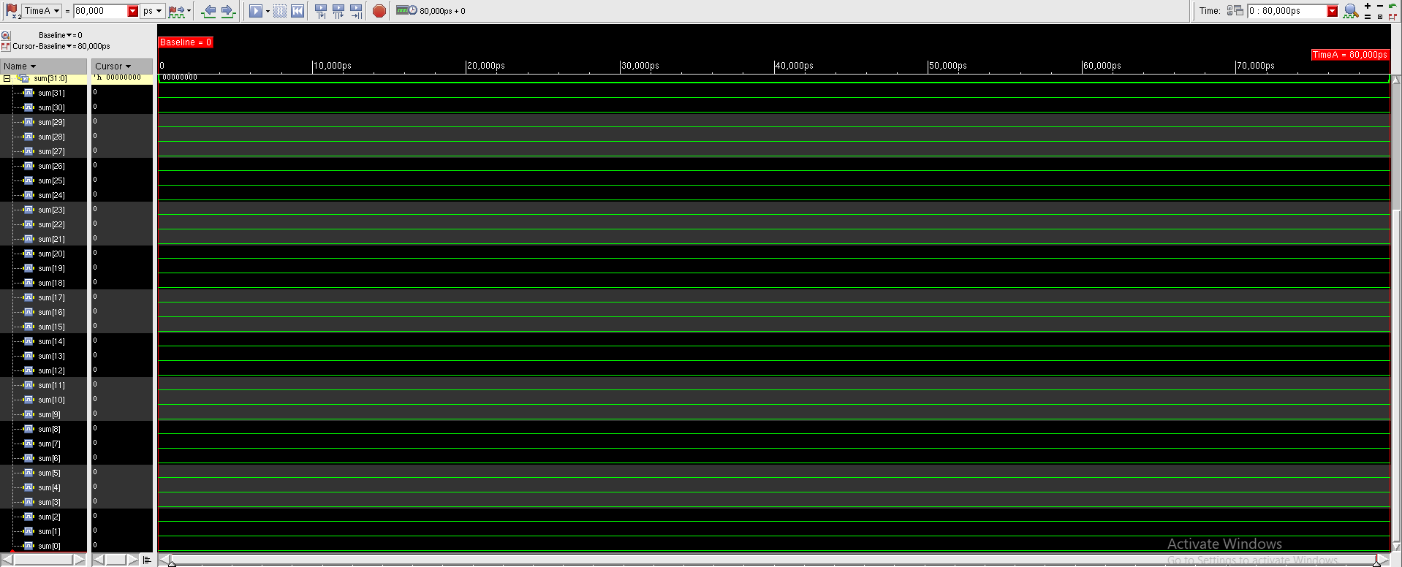

Figure-1.6. Adder_32bit_8_stage.g - a 10 ns clock definition, clock transition and uncertainty settings, and input/output delay constraints for rst and count.
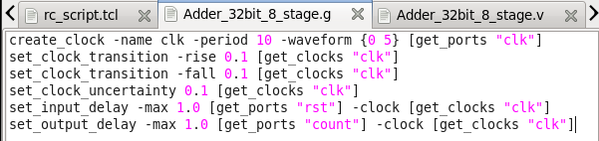

Figure-1.7. rc_script.tcl - sets the library and search paths, reads and elaborates the RTL, reads the SDC constraints, synthesizes to a mapped netlist, reports timing and power, and writes out the netlist and SDC.
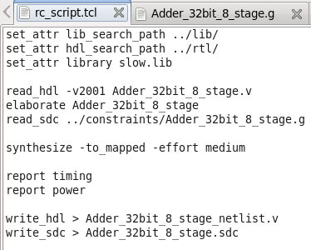

Figure-1.8. ls -lh confirming that Adder_32bit_8_stage.v, slow.lib, Adder_32bit_8_stage.g, and rc_script.tcl are all present
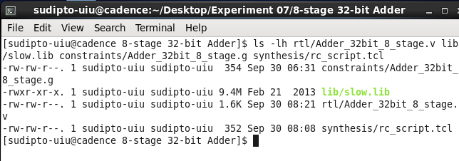

Figure-1.9. rc terminal output at the end of synthesis, showing the timing report, the power report, and confirmation that the SDC export finished
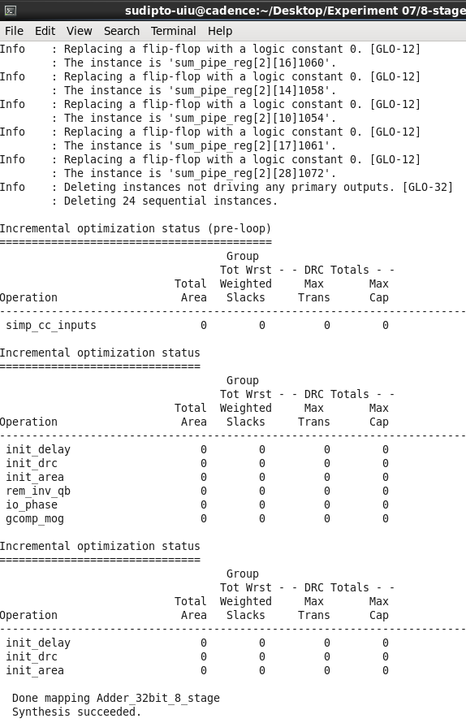

Figure-1.10.1 Cadence RTL Compiler schematic view of the synthesized 8-stage pipelined adder (captured here for an equivalently pipelined design named pipelined_32b_adder; your own hierarchy panel will show Adder_32bit_8_stage). The repeated ripple and register structure across the width of the schematic corresponds to the eight 4-bit addition stages.
Part-1
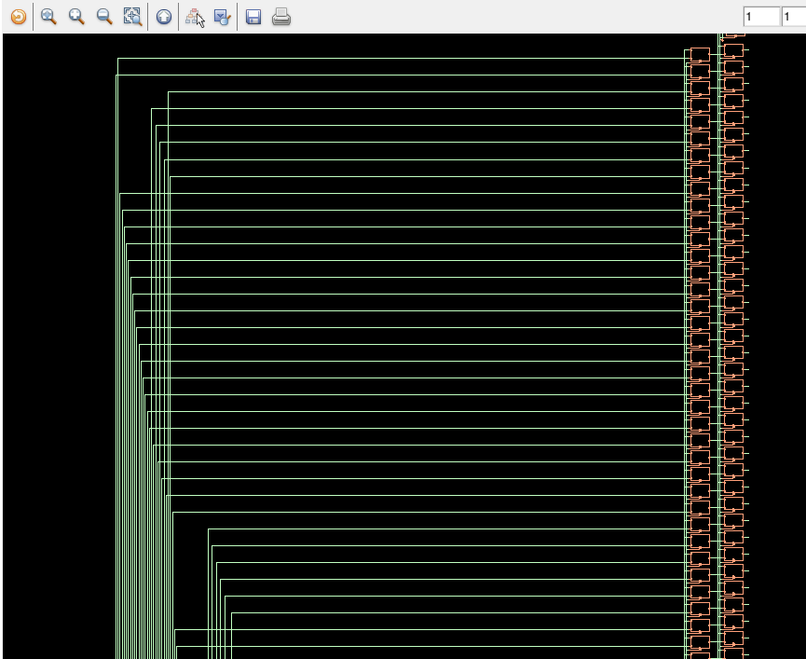

Figure-1.10.2 Cadence RTL Compiler schematic view of the synthesized 8-stage pipelined adder (captured here for an equivalently pipelined design named pipelined_32b_adder; your own hierarchy panel will show Adder_32bit_8_stage). The repeated ripple and register structure across the width of the schematic corresponds to the eight 4-bit addition stages.
Part-2
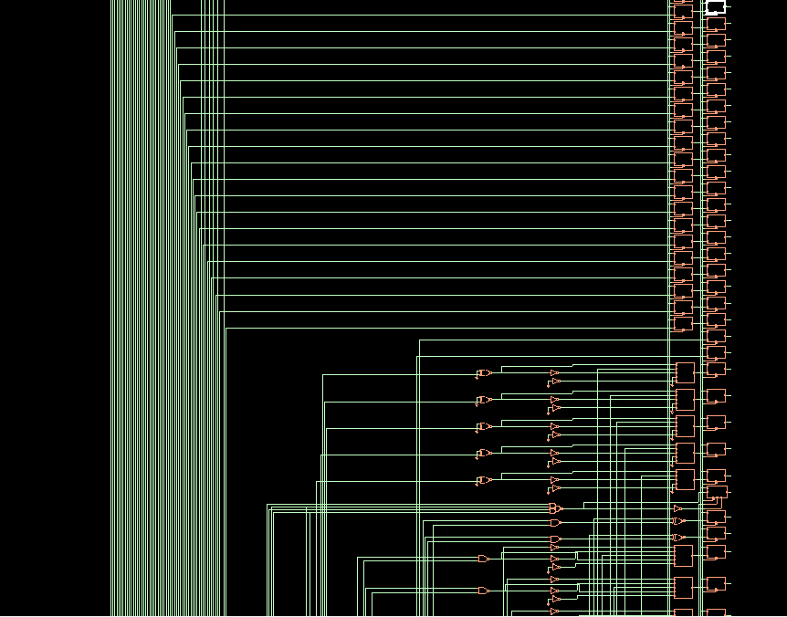

Figure-1.10.3 Cadence RTL Compiler schematic view of the synthesized 8-stage pipelined adder (captured here for an equivalently pipelined design named pipelined_32b_adder; your own hierarchy panel will show Adder_32bit_8_stage). The repeated ripple and register structure across the width of the schematic corresponds to the eight 4-bit addition stages.
Part-3
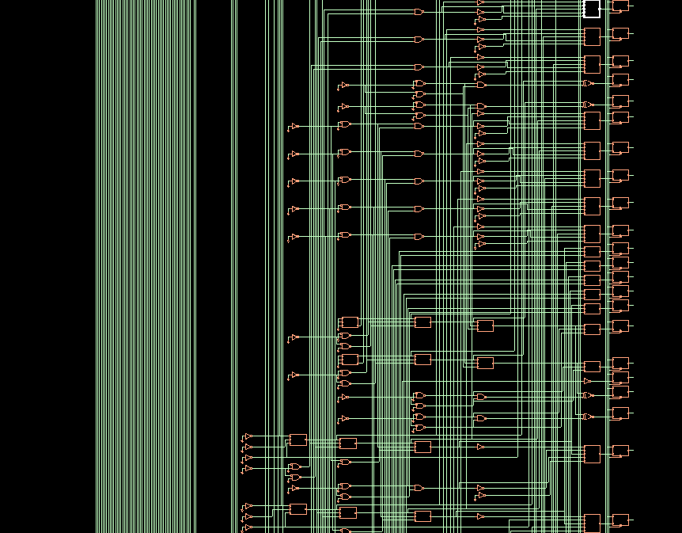

Figure-1.10.4 Cadence RTL Compiler schematic view of the synthesized 8-stage pipelined adder (captured here for an equivalently pipelined design named pipelined_32b_adder; your own hierarchy panel will show Adder_32bit_8_stage). The repeated ripple and register structure across the width of the schematic corresponds to the eight 4-bit addition stages.
Part-4
